**MODELS AND MIGRATIONS**

DJANGO HAS A GREAT FEATURE WHICH CONSIST TO DO A REVESE ENGINEERING WITH ANY MODEL WE CREATE, SO FIRST ABLE WE ARE GOING TO CREATE OUR MODELS: UserProfile and UserProfileManager:

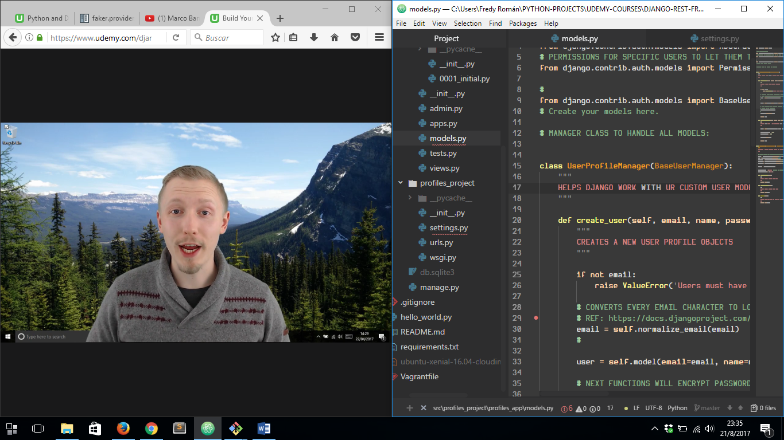

THEN WE HAVE TO SPECIFY IN ***settings.py*** FILE OUR ***AUTH_MODEL*** IS OUR ***profiles_app.UserProfile***

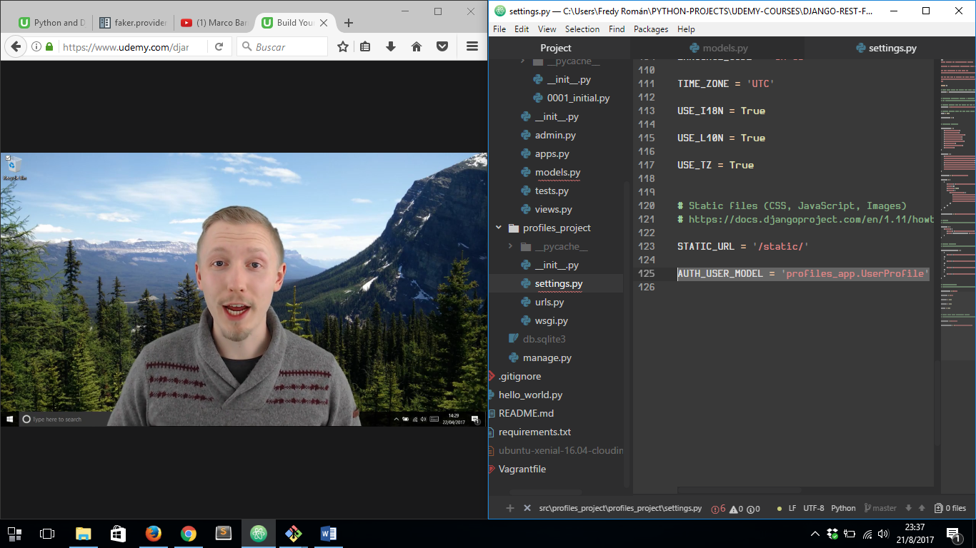

AND FINALLY WE HAVE TO RUN NEXT COMMANDS:

1. ***python manager.py makemigrations***
2. ***python manager.py migrate***

